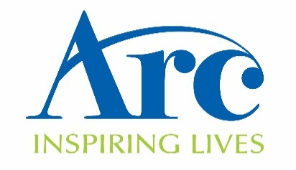
Please return this form to:
Rosie Hather
Arc, 7 The Crescent, Taunton, TA1 4EA
rhather@arcinspire.co.uk

Yes, I would like to make a donation to support the work of Arc
Your Donation
Please accept my donation of: £___________
☐I have enclosed a cheque / CAF voucher made payable to ‘Arc’
☐I have paid my donation directly into your bank account:
Natwest, Sort Code 60-80-06, A/C 60108150, using the reference: _______

Your Details
Title: First Name: Surname:____________________
Address: ______________________________________________________
Post Code: ____________________
Email: _____________________ Telephone: ______________________

Signature: _____________________ Date: _____________________
Contact Preferences
We would like to contact you to thank you for your gift and update you on our work and upcoming events and campaigns. Please let us know how you would like to hear from us:
By Post ☐ By email ☐ By Telephone ☐
I would not like to receive communications from Arc ☐

Gift Aid - Please make your gift go further!
Do you pay tax? If so, by ticking the box below you can make your
donations worth a quarter more, at no extra cost to you. For every
£1 you donate, Arc can claim an extra 25p from HMRC.
☐ I am a UK tax payer and I pay an amount of UK income or capital gains tax at least equal to the tax that Arc will reclaim on my donations in the tax year. I will inform you if my circumstances change and I no longer pay an amount of tax equal to the tax that Arc reclaims.

Arc are committed to protecting and respecting your privacy. If you would like to know more about how we collect, store and use your data, you can view our Privacy Statement on our website at:
www.arcinspire.co.uk/About-Us/privacy-statements

