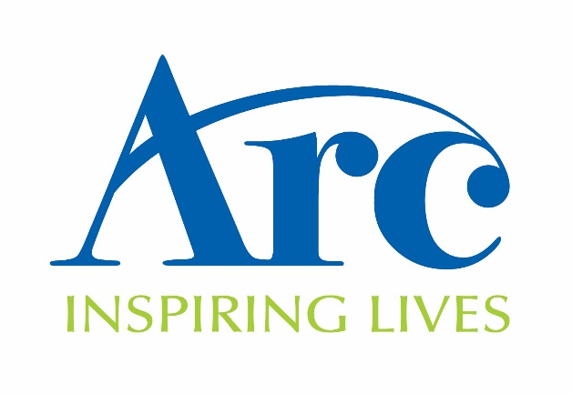
Sponsorship Form
Participants Name………………………………………….
Address……………………………………………………...
.................................................. Post Code……………..
I have chosen to ………………………………………......
on behalf of Arc. Please show your support by sponsoring me.

Formerly Taunton Association
for the Homeless

Make your sponsorship go further! Using Gift Aid means that for every £1 you give, we can get an extra 25p from the government, helping your sponsorship to go further at no extra cost to you! In order for us to claim gift aid, we must have a full name, house address/name and postcode and a ticked box! Please help us to claim an extra 25p per £1 by filling out your details in full.

By ticking to claim Gift Aid, you are stating that you are a UK tax payer and would like Taunton Association for the Homeless to treat all donations that you have made in the past five years and any future donations from today, until said otherwise, as Gift Aid donations. In order to claim Gift Aid you must have paid an amount of income tax/and or capital gains tax equal to the tax reclaimed.

Sponsor Full Name | Address  (Please fill in at least your house number/name) | Postcode | Gift Aid (please tick if you are a UK tax payer) | Amount

